**VISVESVARAYA TECHNOLOGICAL UNIVERSITY, BELGAUM 59014**



Software Engineering Project Report on

**“General Parking Management System”**

By

**Tony J Mathew (1BM17CS119) Tanmay Goel (1BM17CS112)**

Under the Guidance of

**Prof. Latha N. R.**

Assistant Professor, Department of CSE

BMS College of Engineering

Software Engineering Project carried out at



Department of Computer Science and Engineering

BMS Collegeof Engineering

(Autonomous college under VTU)

P.O. Box No.: 1908, Bull Temple Road, Bangalore-560 019

2019-2020

**BMS College of EngineerinG**

**DEPARTMENT OF COMPUTER SCIENCE AND**

**ENGINEERING**



***CERTIFICATE***

This is to certify that the Internet of Things project titled “**General Parking Management System**” has been carried out by **Tony J Mathew (1BM17CS119) and Tanmay Goel (1BM17CS112)** during the academic year 2019-2020.

Signature of the guide

**Prof. Latha N.R.**

Assistant Professor

Department of Computer Science and Engineering

BMS College of Engineering, Bangalore

**Examiners**

**Name Signature**

**1.**

**2.**

**BMS College of EngineerinG**

**DEPARTMENT OF COMPUTER SCIENCE AND ENGINEERING**



***DECALARATION***

We , Shreyas K (1BM17CS098) , Tarun M Krishna (1BM17CS116) , Tarun Venkatesh H (1BM17CS117) and Tony J Mathew (1BM17CS119) students of 5th Semester, B.E, Department of Computer Science and Engineering , BMS College of Engineering, Bangalore , hereby declare that , this IoT Application development work entitled

"Data Transmission Through Light" has been carried out by us under the guidance of **Prof. Antara Roy Choudhury**, Assistant Professor, Department of CSE, BMS College of Engineering, Bangalore during the academic semester Aug-Dec 2019.

We also declare that to the best of our knowledge and belief, the development reported here is not from part of any other report by any other students.

Signature

Tony J Mathew (1BM17CS119)

Tanmay Goel (1BM17CS112)

**General Parking Management System**

**Introduction**

Cities develop, and simultaneously the technology. Number of cars and bikes are increasing. But the space available remains the same. Well, management on roads still remains a challenge, but not elsewhere.

Our General Parking Management System is designed to oversee parking in various public places, such as shopping malls, airports, railway stations, metro stations and where not. Vehicles can just enter the parking area, without collecting any ticket. During exit, the vehicles can just leave without waiting in a queue to pay for parking. Payment happens online, so the driver need not worry. Definitely the solution looking ahead.

**Software Requirement Specification**

**User Requirements**

1. The user should be automatically allowed entry into parking lot and payment must be handles without user input.
2. Separate lane / requirements must be provided for new/un-registered users

**System Requirements**

1. The user should have a parking card and it must be pasted inside front window of car, or in the front of a bike.
2. User must link digital wallet to the system.
3. User receives mail containing details of transaction.
4. User must have specified minimum balance in wallet.

**Functional Requirements**

1. Every user receives a card with a unique ID.
2. The user’s digital wallet is linked to the system and can be identified using card ID.
3. When user is allowed entry into parking lot, the time is registered.
4. When user exits parking lot, time is registered and payment is made.
5. If payment is insufficient, user is informed to top-up wallet.
6. System contains information regarding which parking spaces are currently occupied.
7. New users are given location of available parking spots. If no parking spots are available, they are informed.

**Non-Functional Requirements:**

**Product Requirements**

1. Multiple scanners must be provided at both entry and exit
2. Payment card must not be duplicable

**Organizational Requirements**

1. The system development process and deliverable documents shall conform to the process and deliverables defined in XYZCo-SP-STAN-95

**External Requirements**

1. The system shall not disclose personal information about customer apart from name and reference ID to system operators. Account details must be secure so as to prevent misuse.

**Domain Requirements**

1. Updated card balance must be accessible after scan at every entry/exit

**Form Based Specification**

|  |  |
| --- | --- |
| **Automatic Parking System** | |
| **Function** | Automatic Entry and Exit to and from parking lot. Automatic parking fee payment. |
| **Description** | It allows automatic entry and exit to and from parking lot. The parking fee to be charged is calculated and automatically deducted from linked account. |
| **Inputs** | User Id, Time of Entry, Time of Exit, Parking Slot Availability |
| **Source** | FASTag Reader at Entry and Exit Gate, Parking Slot Load Cell |
| **Outputs** | Open Gate, Deduct calculated bill amount from linked account, Location of available parking slot |
| **Destination** | Customer Database, Main Control Loop |
| **Action** | FASTag Reader reads card ID of entering and exiting vehicles. The card ID is verified with the customer database. Load cells are present at all parking slots to check if it is occupied. If ID is valid and parking slot is available (entry only), the gate opens and the time of entry and exit are registered at respective gates. User is given the location of an available parking slot which is displayed on an LCD screen above gate. The bill is calculated on exit based on entry and exit times. The bill amount is then charged from the linked user account. Bill details are sent to user. |
| **Requires** | Card ID to verify with customer database. Load cell sensor data to check parking slot availability. Entry and Exit timings to calculate bill. |
| **Pre-Condition** | User must have Parking Service Card. Linked account must have minimum fare amount. |
| **Post-Condition** | If linked account has insufficient balance, user must be informed to add money to linked account. Pending fees stored in Customer Database. |
| **Side Effects** | None. |

**Design Models**

**Data Flow Model**

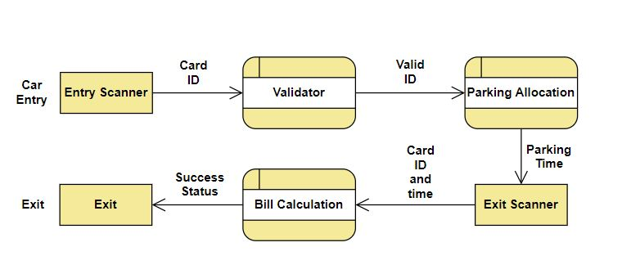

**Detailed Description of Model**

ID is scanned by the scanners at the entrance. Valid ID cars are allowed in. Time is stored. At the Exit, duration of parking taken. Bill rates are fetched. Bill is calculated. On successful payment, car is allowed to exit. Top-up can be done securely using a simple mobile app.

**Architectural Design**

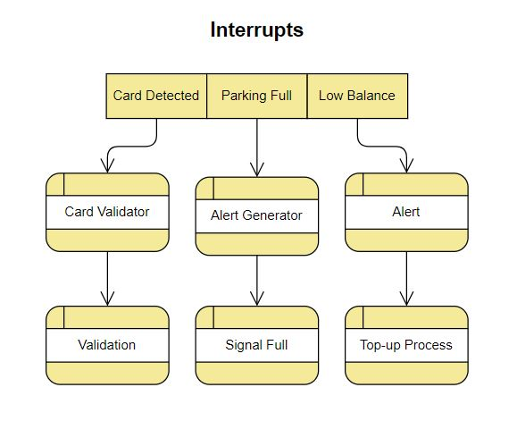

**Detailed Design**

**Use Case Diagram**

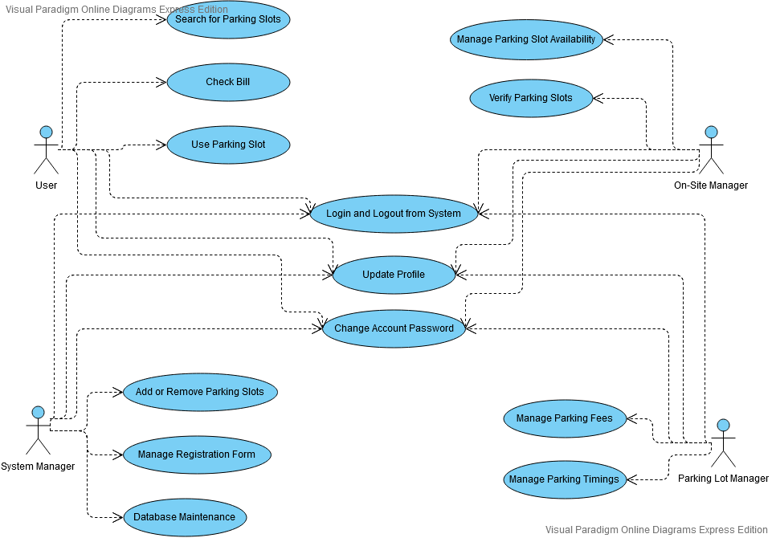

**Sequence Diagram**

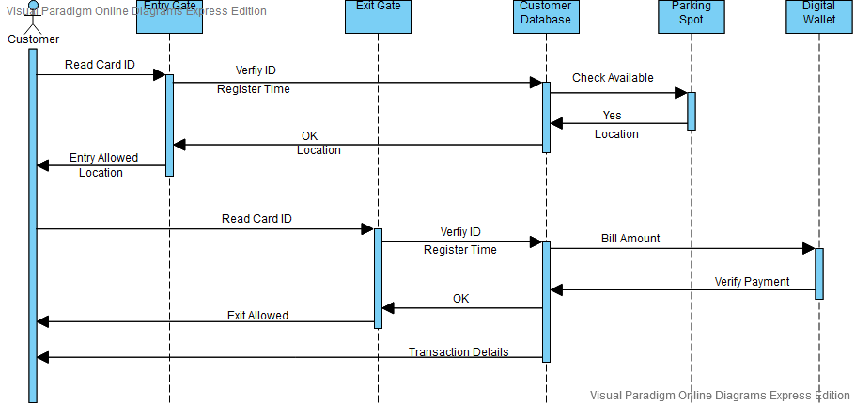

**Cost Estimation**

Let no. of parking spots = 5000 => 5000 load sensors required, at $3/sensor

3 scanners at the entrance and 3 at the exit, at $20 per scanner

Code length=1000 LOC, with rate $3/LOC

Labour cost: $1500

Total Cost: (1000*3) + 1500 + (6*20) +(5000*3)=$19620

**Test Cases**

**Title:** Parking Lot – Entry

**Description:** A registered user should be able to allowed entry to parking lot.

**Precondition:** The user must already be registered to the service with an email address and password.

**Assumption:** The user has membership card stuck inside front window of car.

**Test Steps:**

1. Drive car to entry gate.
2. Card is scanned by FASTag Reader.

**Expected Result:** Entry gate opens if space is available in parking lot. Location of free parking spot is displayed on screen. Time of entry is registered into customer database.

**Title:** Parking Lot – Parking Spot Availability

**Description:** System should know if parking spot is available and location of available parking spots.

**Precondition:** Load Cell at every parking spot.

**Assumption:** Free parking spot available.

**Test Steps:**

1. Check for available parking spots in database.
2. Drive car to parking spot.
3. Check database.
4. Drive car out of parking spot.
5. Check database.

**Expected Result:** If car is parked in a parking spot, the location should be updated in database and marked as unavailable. If car leaves parking spot, it should be marked as available.

**Title:** Parking Lot – Exit

**Description:** A registered user should be able to allowed exit from parking lot and payment automatically deducted from linked account.

**Precondition:** The user must already be registered to the service with an email address and password.

**Assumption:** The user has membership card stuck inside front window of car.

**Test Steps:**

1. Drive car to exit gate.
2. Card is scanned by FASTag Reader.

**Expected Result:** Exit gate opens if sufficient balance is present in linked account. Bill payment carried out automatically. Mail is sent to user giving details of transaction.

**Conclusion**

General Parking Management System is a very diverse solution, which is simple yet very secure, which has large applications, primarily to manage large crowd parking. This can be implemented anywhere, thus is definitely a potent solution to the increasing parking issues.